CHAPTER 5: Separating mixtures
Worksheet 5.6

What do you know?
Science Quest 7: pages 194–196
Student: Class:

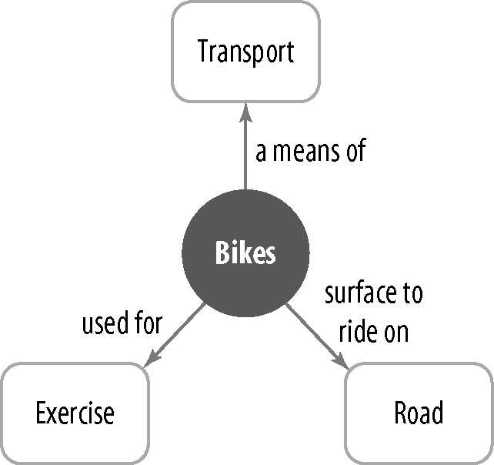
Concept maps are thinking tools that can be used to illustrate your understanding of a set of ideas. You can use a concept map to show how key ideas are linked together. A central idea, item or theme is shown in the middle box. Usually you use words to show these connections, and arrows to show the direction in which it should be read. Software such as Inspiration® or SmartDraw® can also be used to create concept maps.
1. Working in groups of three, use the words on the right to make your own concept map below about separating mixtures.
2. Add your own words and arrows to describe the connection. You can also make extra oval-shaped discs for terms that you would like to add to the list.
